



**CRICKET ANALYSIS WITH INTERACTIVE VISUALS USING ALTAIR**

Team Member Details

Shivendra Jogi – 10511272

Vageesh Meludurgamutt Shivaprasad - 10510254

Prasanth Roy – 10511973

Nandish Kumar Bngalore Jayaram – 10510517

**TABLE OF CONTENTS:-**

Introduction 1

Dataset 1

Visualization and Insights 1

**Github link :** <https://github.com/10511272/CRICKET-ANALYSIS-WITH-INTERACTIVE-VISUALS-USING-ALTAIR/blob/master/10511272.ipynb>

**Introduction :**

Cricket is a sport which is played between 2 teams consisting of 11 players each. These 11 players score runs(points) which is done by smashing the ball across a circular shape ground or by running between the wickets on both ends of the pitch. The wickets are a set of three small wooden posts and the pitch is a rectangle of short grass.

This sport was first played by England in the 16th Century and today it is a popular sport in England, India, Pakistan, Australia, New Zealand, South Africa, Bangladesh, Sri Lanka.

**Dataset :**

The Dataset ‘ODI batting’ consist of records of the batsman from all the nations that have been playing cricket till now. It also conists of the runs scored by each batsman in their entire cricketing career. The dataset was chosen from github.com.

**Visualization And Insights :**

1. Three Dimensional Visualisation of top 3 run scorers vs all teams

The visualization below is a three dimensional interactive graph which shows the top three teams which have scored the most runs against all the teams. In the colab we can see that India has been dominant over the recent years in terms of scoring runs followed by Australia and West indies respectively.

1. Mean of runs scored by the top batsman from top 6 nations.

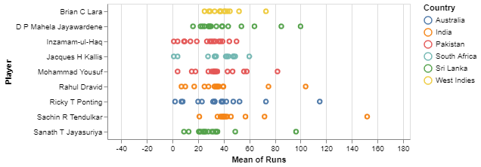

In this Visualization, we can see that there are the top nine batsman of all time on the y axis and their mean of runs of the x axis. Out of these nine that we have, It is quite visible from the naked eye that Sachin R Tendulkar from India has stood out from the rest because of the runs he has scored.

1. Amount of runs scored by the top 6 teams against the rest

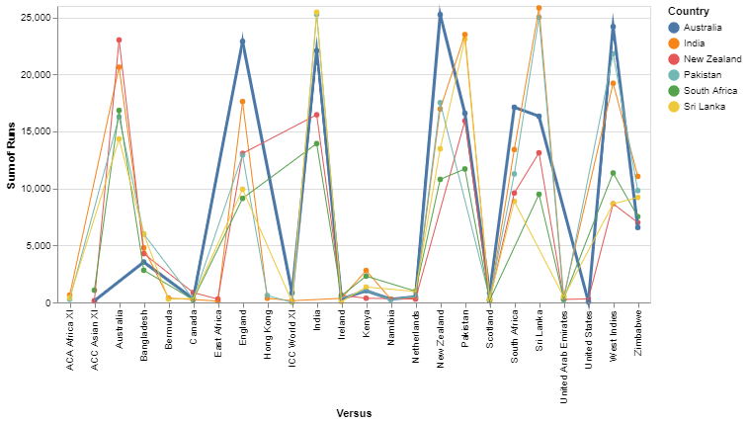

The above visualization is an overview of the amount of runs scored by the top 6 ranked teams in the world of cricket against the rest of the teams that play international cricket. In this visualization as well it turns out that the Indian team has scored their maximum chunks of runs against the Sri Lankans. Whereas the lowest that they have scored is against Kenya because of the lack of international cricket for the Kenyan team.

1. Increase in the number of runs scored over the years

As we all know that the British were the ones to initiate this sport and gradually the nations joined and started playing this sport. So until 1975, the number of runs scored were too less because of the sport not being recognised internationally. But as years progressed the number of runs scored increased and progressed too. There is a clear increase in the trend.

1. Comparison Between the Top 3 batsman of All time

1. Top 6 countries based on Total Runs scored

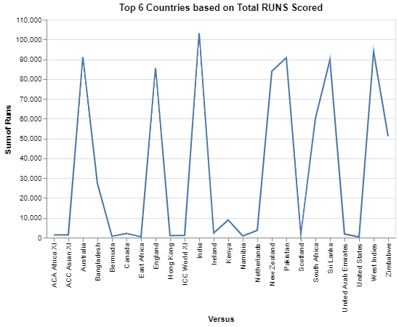

1. Comparison of Top 4 Batsmans in terms of runs scored and their mean score rate.

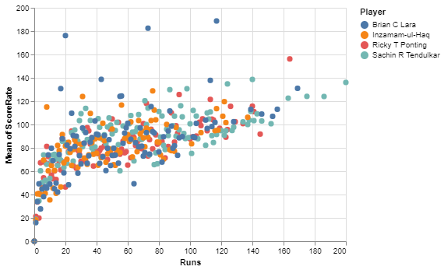

1. Sum of runs scored month wise from the year 1972 to 2011

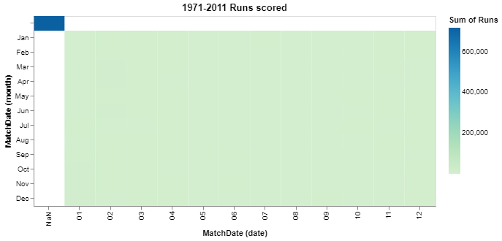

1. Highest runs scored by the batsamn of all countries

1. Total number of runs scored by each country till date

